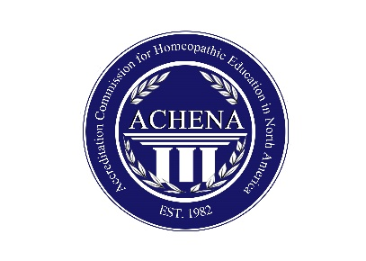
Criteria for Approval of Continuing Professional Development Credits
Professional homeopaths should have a life-long commitment to studying the art and science of homeopathy. Completing formal Continuing Professional Development programs along with ongoing independent study, reflection on practice and consultation with clinical supervisors and colleagues is critical for professional growth.
As an accrediting body for homeopathic education, ACHENA reviews applications for continuing professional development programs from homeopathy schools and homeopathic educators. In order to receive ACHENA approval as a continuing professional development program for a designated number of hours, the following criteria must be met:
- The description of the program explicitly states it is intended for practicing professional homeopaths
- The program covers content which is more advanced or more in-depth than material outlined in the course of study in ACHENA’s current Accreditation Manual or the Standards for Education and Competencies for the Professional Homeopathic Practitioner in North America
- Program organizers have completed an application for CPD hours that:
  - Describes evidence of need for such a program by practicing homeopaths
  - Articulates the specific gap in practice that the program seeks to address
  - Outlines specific measureable learning objectives appropriate to a practicing professional homeopath
  - Clearly describes the length of the program
  - Clearly describes teaching modalities used to achieve stated objectives
- The program is taught by a qualified individual who has a CCH, other recognized homeopathic credential or community recognized level of expertise in homeopathy
- The program organizers and /or educator systematically collects and reviews feedback and evaluation data from program participants, uses this information to improve future programs and makes this information available for review by ACHENA.

